
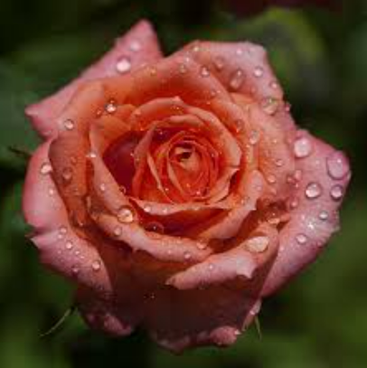
Something to look forward to!
The 2026 Carolina District Mid-Winter Meeting, hosted by the Greater Greenville Rose Society will be held at the beautiful Brookstown Inn in Winston-Salem on Friday, January 23rd - Saturday January 24th.
More information, registration, and schedule will be coming soon. As always, there will be wonderful speakers, vendors, and great food. You won’t want to miss it!
Brookstown Inn
200 Brookstown Ave
Winston-Salem, NC 27101
www.brookstowninn.com
$130 per night (mention ARS District Rose Meeting)

For more information or to be put on our official mailing list, please contact:
Frank Van Lenten-fvanlenten@charter.net
Rita Van Lenten-ashgram1@charter.net
Kim Austin-kimaustin@bellsouth.net

